***“Heaven’s Light is Our Guide”***



**Department of Computer Science & Engineering**

**RAJSHAHI UNIVERSITY OF ENGINEERING & TECHNOLOG**

**Lab Report**

|  |
| --- |
| **Submitted By:**  **Name: Khandoker Sefayet Alam**  **Roll:2003121**  **Department: Computer Science & Engineering**  **Section-C**    **Course code: CSE 3102**  **Course name: Database Management System** |

|  |
| --- |
| **Submitted To:**  **Barshon Sen** |

❖Query 1.1:

Display the name, IMDb rating and genre of all the movies with an IMDB rating greater than or equal to 8.0.

code:

SELECT Movie_Name,IMDB_Rating,Genre FROM movie WHERE IMDB_Rating>=8;

table:

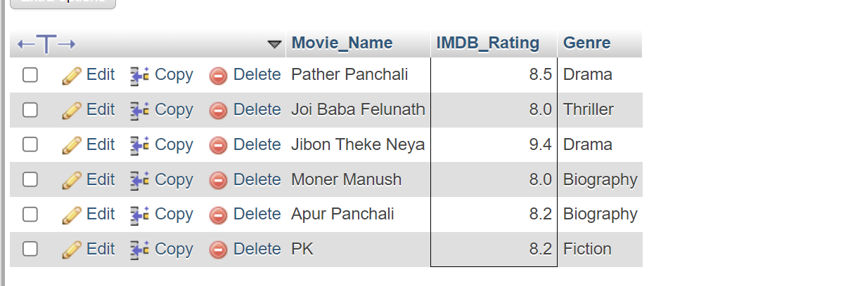

Query 1.2:

Find how many movies are there in each genre with an IMDB rating greater than or equal to 8.0.

code:

SELECT COUNT(Movie_Name) cnt,Genre FROM movie WHERE IMDB_Rating>=8 GROUP BY Genre;

table:

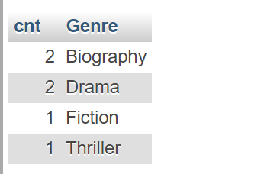

Query 1.3:

Find the name and the average IMDb rating of those genres whose average IMDb rating is greater than or equal to 8.0.

code:

SELECT Genre_AVG,Genre FROM (SELECT AVG(IMDB_Rating) As Genre_AVG,Genre FROM movie GROUP BY Genre) as GENRE_TABLE WHERE Genre_AVG>=8.0 ;

table:

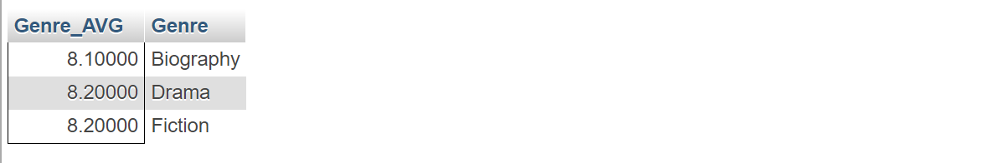

Query 1.4:

Find the name, number of films and number of awards of the director who directed the most number of movies.

code:

SELECT Director_name,No_of_Film,No_Of_awards from director WHERE No_of_Film=(SELECT max(No_of_Film) from director);

table:



Query 1.5:

Find the name, current age, number of films and number of awards of the youngest actor.

code:

SELECT actor_name,Year(Now())-Birth_year as Current_age,No_of_Film,No_Of_awards from actor WHERE Birth_year=(SELECT max(Birth_year) FROM actor);

table:



Query 2.1:

Find the name, number of films as a director, number of films as an actor, number of awards as a director and number of awards as an actor of all the directors. (If a director never acted in any film then number of films and number of awards as an actor will be ***null***)

code:

SELECT director.Director_name, director.No_of_Film as directed_films, director.No_Of_awards as Awards_as_director, actor.No_Of_Film as Films_acted, actor.No_Of_Awards as Awards_as_actor FROM director LEFT JOIN actor ON director.Person_Id=actor.Person_ID;

table:

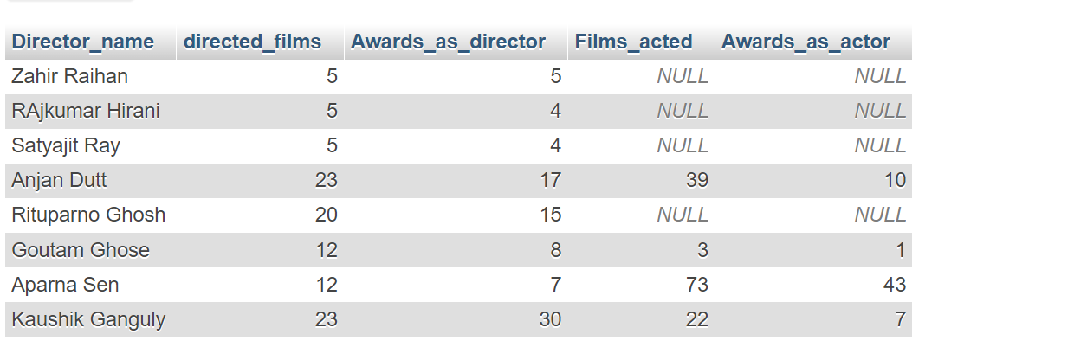

❖ Query 2.2: Find the name, number of films as a director, number of films as an actor, number of awards as a director and number of awards as an actor of all the actors and directors.

Code:

SELECT director.Director_name, director.No_of_Film as directed_films, director.No_Of_awards as Awards_as_director, actor.No_Of_Film as Films_acted, actor.No_Of_Awards as Awards_as_actor FROM director LEFT JOIN actor ON director.Person_Id=actor.Person_ID UNION

SELECT actor.Actor_Name, director.No_of_Film as directed_films, director.No_Of_awards as Awards_as_director, actor.No_Of_Film as Films_acted, actor.No_Of_Awards as Awards_as_actor FROM actor LEFT JOIN director ON director.Person_Id=actor.Person_ID

Table:

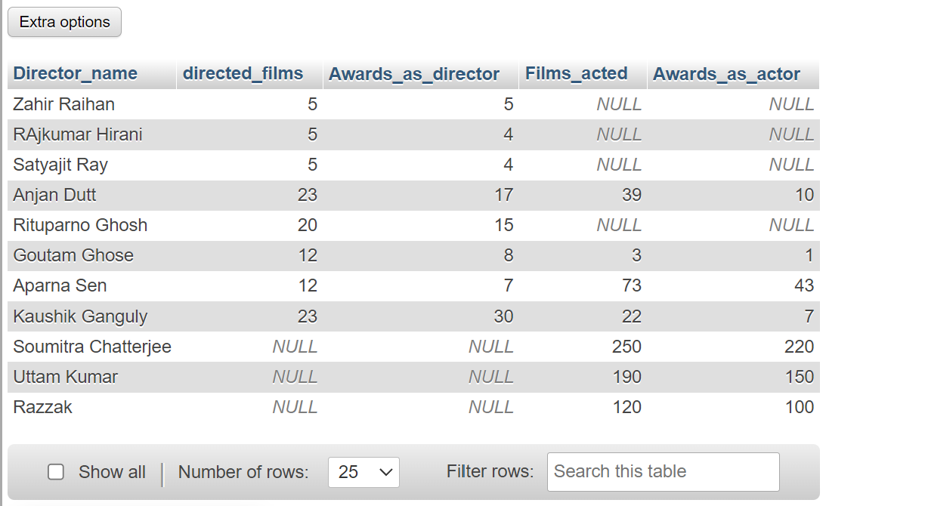

❖ Query 2.3: Find the name, number of films and number of awards of those actors who never directed any film.

Code:

SELECT actor.Actor_Name, director.No_of_Film as directed_films, director.No_Of_awards as Awards_as_director, actor.No_Of_Film as Films_acted, actor.No_Of_Awards as Awards_as_actor FROM actor LEFT JOIN director ON director.Person_Id=actor.Person_ID WHERE director.No_of_Film is NULL;

Table:

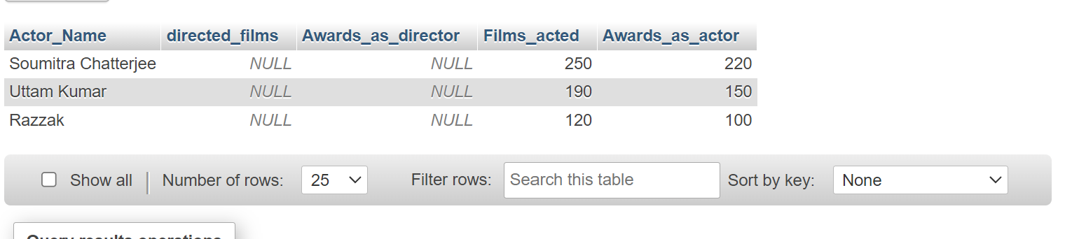

❖ Query 2.4: Find the name, IMDb rating and genre of those movies whose IMDb Rating is above average.

Code:

SELECT Movie_Name,IMDB_Rating,Genre FROM movie WHERE IMDB_Rating>(SELECT AVG(IMDB_Rating) FROM movie);

Table:



❖ Query 2.5: Among the average IMDb ratings of all the movie genres, find

the highest average IMDb rating.

Code:

SELECT MAX(IMDB_MAX_AVG),Genre FROM (SELECT AVG(IMDB_Rating) as IMDB_MAX_AVG,Genre FROM movie GROUP BY Genre) as derived;

Table:

